Introduction

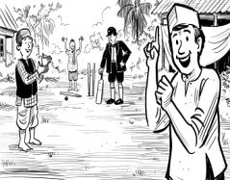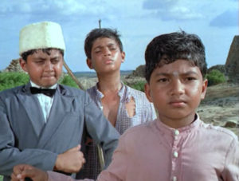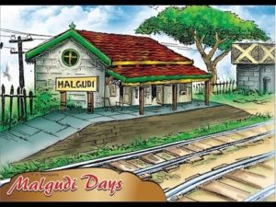

R K Narayan. R. K. Narayan was born in Madras, South India, and educated there and at Maharaja's College in Mysore. His first novel Swami and Friends (1935) and its successor The Bachelor of Arts (1937) are both set in the enchanting fictional territory of Malgudi. Malgudi is located on the banks of the fictional river Sarayu, near the also-fictional Mempi forest, on border of the states of Mysore and Madras and a few hours' away from Madras.

Swami and Friends was the first novel by R.K.Narayan one of the famous Indian writer in English.
Swami and Friends is the first novel of the trilogy that is set in the fictional town of Malgudi. It is also set in British India- 1930.
Swami’s friends are also introduced- Somu the monitor, Mani the mighty, good for nothing, Sankar the most brilliant and Samuel the pea (based on his size).

Rajam and Mani:
River SARAYU the pride of Malgudi is introduced. It is here Swami and his friends spend most of their leisure. Rajam, a new student in their class who spoke English ‘exactly like a “European”’ was respected above all (English was to be feared and respected in British India). In addition, he was police superintendent’s son. Thus Rajam was rival to Mani and so Swami would act as a cord of communication between them. Soon they became good friends at the banks of Sarayu.

Swami’s Grandmother:
Swami spends most of his time with his granny (which is absent in today’s kids) and shares his admiration for his new friend Rajam. Soon the weekend comes and Swami waits for his dad to leave and then sets out to meet his friends. He spends time at Rajam’s home with Mani. Rajam shows his attitude as superintendent’s son.

School breaks up:
During the examination, Swami writes short answers and completes his exam before his friends. After the exams vacations began with the final ‘prayer’. Students leave the campus with a lot of fun throwing ink on each others shirt that marks the colourful beginning.
W.S. Swaminathan: A ten-year-old boy studying at Albert Mission School, Malgudi. He lives in Vinayaka Mudali Street. He is later transferred to Board High School.
Mani: Swami's classmate at Albert Mission School, lives in Abu Lane, he is known as 'Mighty good-for-nothing'. He carries around a club sometimes, and threatens to beat his enemies to a pulp.
M. Rajam: Swami's classmate at Albert Mission School, lives in Lawley Extension. His father is the Deputy Police Superintendent of Malgudi. He previously studied at an English Boys' School, Madras. He is also the Captain of Malgudi Cricket Club (Victory Union Eleven).
Somu : Monitor of 1st Form A Section, lives in Kabeer Street. He fails in 1st Form and is "automatically excluded from the group".
Sankar: Swami's classmate in 1st Form A Section. His father gets transferred at the end of the term. He is the most brilliant boy of the class.
Samuel ("The Pea"): Swami's classmate in 1st Form A Section. He is known as "The Pea" because of his height.

